Data Visualizing/ Clustering Intuition

1) Minus –

2) Left Parentheses (

3) Right Parentheses

4) Plus

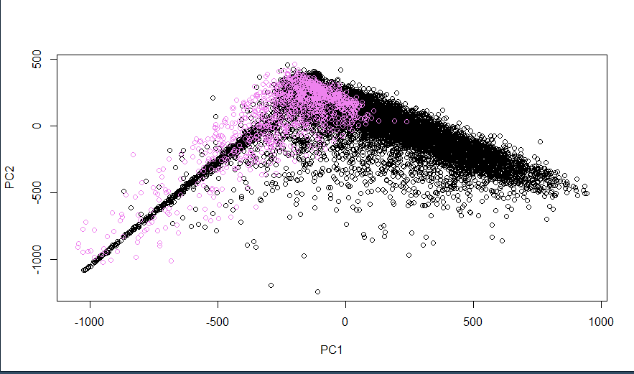

5) equal

6) 0

7) 1

8) 2

9) 3

10) 4

11) 5

12) 6

13) 7

14) 8

15) 9

16) div symbol

17) multiply symbol

18) Everything together

